Project First Stage: Planning

**Project title**: *English Life Club- Enlighten Your Career and Social Network*

**The team**:

Team Name:

All team Members: Jianyue Li**补充**

**Goals or Objectives**

To encourage people who have worked for several years to extend their career development and social network through English life club activities such as sport, travel, photograph, drama, music, English beginner foundation and also business talks.

**Target Users**

**Primary users**: office employees who are in need of career development by improving English or extend social network;

**Secondary users**:potential customer who wants to move and stay in foreign country;

**User characteristics:**

Age and gender: above 21 years old

Work Situation: currently employed or unemployed

Education: high school or above

Computer and web experience: Novice to expert

Purpose: in need of improving oral English in a more flexible and relax environment.

**Features**

**The basic features to be implemented**

Enable a potential member to register as an ELC member;

Enable an ELC member to upgrade and participate off site events;

Provide a comprehensive information about ELC module and available programs;

Provide a comprehensive information about ELC module and up to date programs(normally programs will be updated in one month);

Provide an online and active ELC community where all ELC members can freely share their comments, programs experiences, improvement expected etc

**Features to enhance user experience**

Screen, menu, icon, logo design

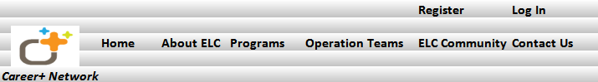

Screen and Menu will be same as above including home, about ELC, Programs, Operation Teams, ELC community and Contact us..

Major function is to introduce ELC to potential members, and encourage them to register and participate.

Logo and icon are shown above

**Usage of colour, font, text, image**

Color combination would be white, light yellow, and grey 

Font, calibri

Text, Calibri and text content would not be very formal.. but in an interesting and fashion expression..

Image: “Program” will be major function that we would like to show customers. We will post many images taken in previous activities, showing encouraging talks, activities, fun meanwhile learning. For example below image:



**Usage of media(sound, animation, movie)**

Front page would be slides changing from one to another showing different photos for varieties of programs.

**Information architecture and navigation systems**



**Technologies**

Front end requirements: Tools?, Languages?

Back end requirements: Tools?, Languages?, Database?

List main functions or tasks or pages

A site diagram (or blueprint)

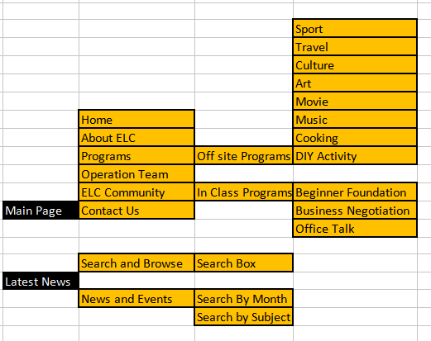

**A series of sketched pages** (home page and a few subsequent pages).

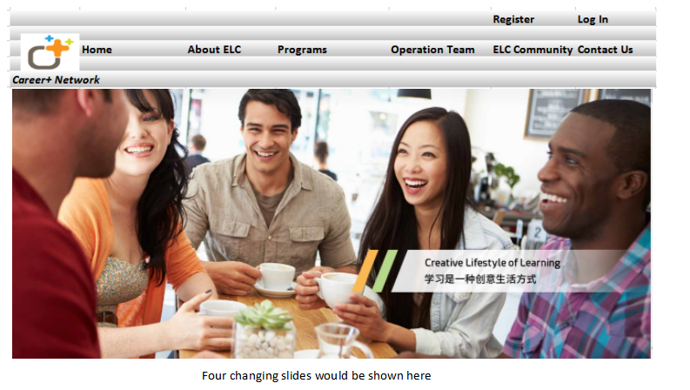

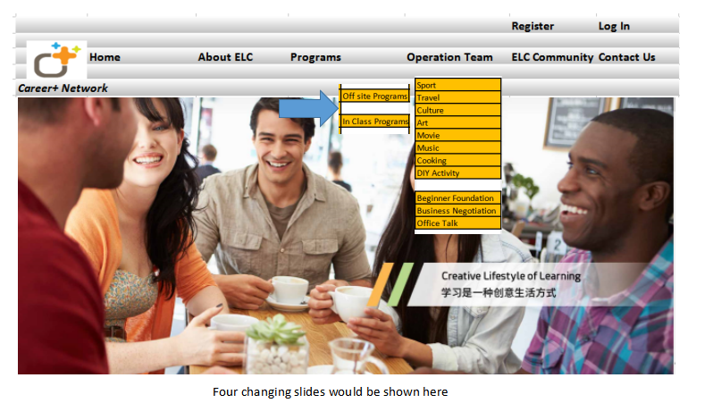

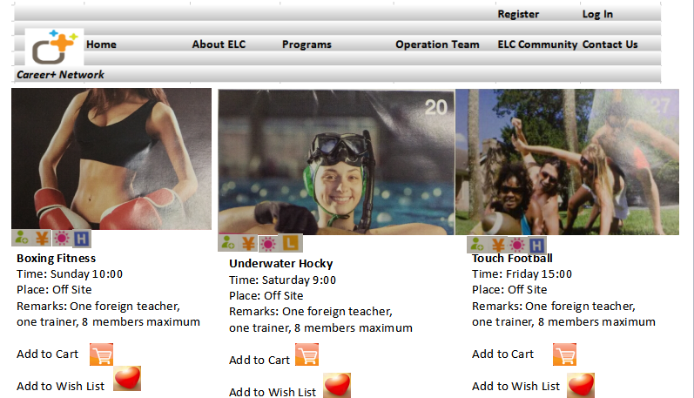

Then members can select the classes they like and see the availability

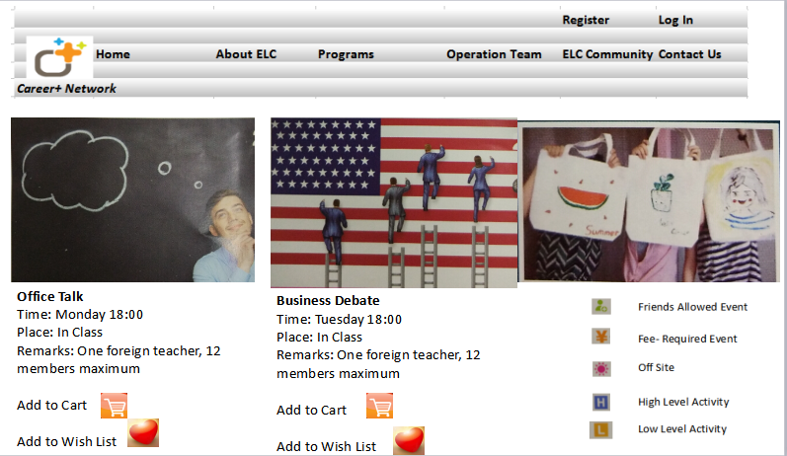

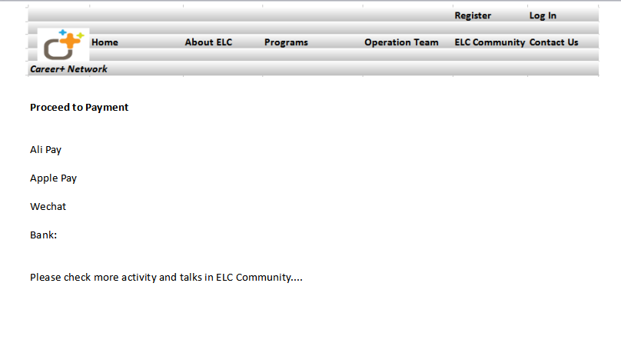

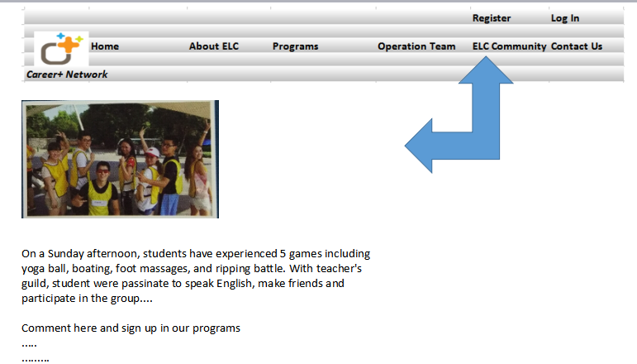

**Data requirements**

For example, user info, product info, order info etc.

ER or class diagram

**Responsibilities 每个成员的优缺点，补充**

Project leader; fully in charge of the scheduling, design, and development of the web

Art Director: good at graphic design, interactive software for example flash, Java

Web Technology Lead : Good at programming, Java and web page design

Site Production Lead :Page coding

Site Editor

Good at Content writing and and editing, very patient

**Schedule**

